**Experiment 9**

**Aim:** Implementing Docker ignore**.**

**Steps:**

**1)** Use the cat command on the Dockerfile to see inside the steps. Currently our app folder contains password.txt file which contains sensitive information.

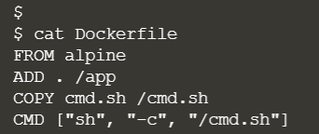

**2)** Using the docker build command to build this Dockerfile.

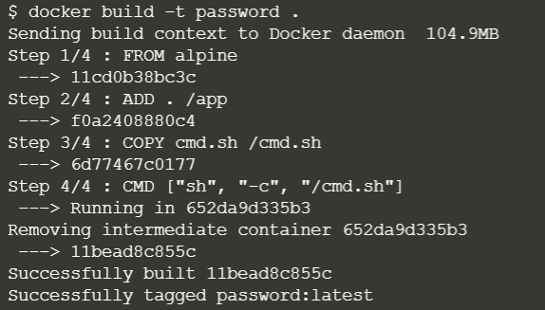

**3)** If we create a container from the image created then we will be able to see the password.txt.

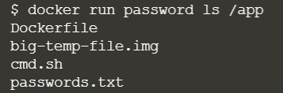

**4)** To ignore this file, we can use **.dockerignore**. Create a .dockerignore file and inside this file write those files name which you want to ignore when building the docker image.  
Now when we build the image we will see the container will not contain password.txt file.

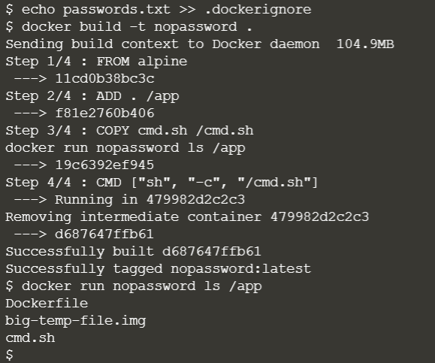

**5)** Using the **.dockerignore** we can also be used to improve the build time of images. For example, suppose an app folder contains a temporary file. Since these files are not required further, these will simply increase build time.

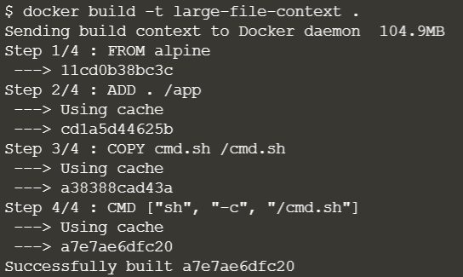

**6)** We can use .dockerignore file to exclude files which we don't want to be sent to the Docker Build Context during the build. To speed up our build, simply include the filename of the large file in the ignore file. When we rebuild the image, it will be much faster as it doesn't have to copy the 100M file.

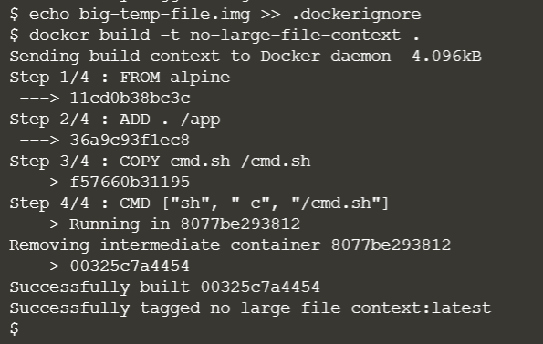

**Submitted by:**

Arjun Rekhi

500068109

R171218028